Name: Katleho Esther Makoane

Assessment: BrightTv Methodology

This case study used a structure data analysis process combining SQL transformations and Excel formulae to derive actionable insights. The steps below outline the methodology followed to clean, enrich, and analyze the dataset:

Data Understanding

1. Source filing:

* Viewership Sheet: Contains session-level logs (Channels, durations and day of the week).

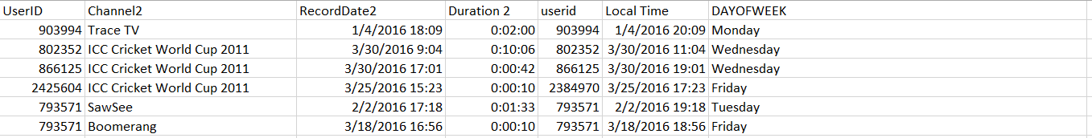

* UserProfiles sheet: Holds demographic details (age, gender and province)

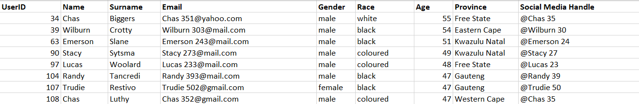

1. Data Preparation in Excel:
2. Time Zone Conversion:

* Field: RecordDate2 (UTC) was converted to SAST (UTC +2)

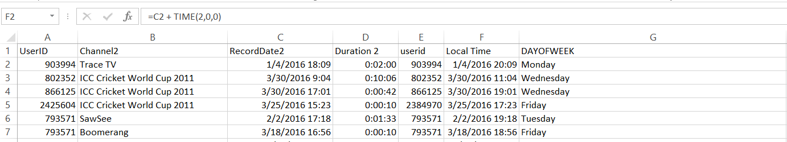

New field: Local Time

1. Time Features Extraction

* Extracted DayOfWeek

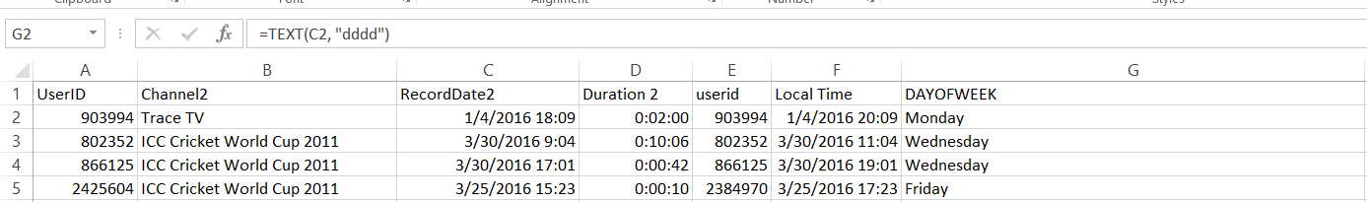

1. Data Enrichment with SQL

* Used Snowflake to count which gender has the most people

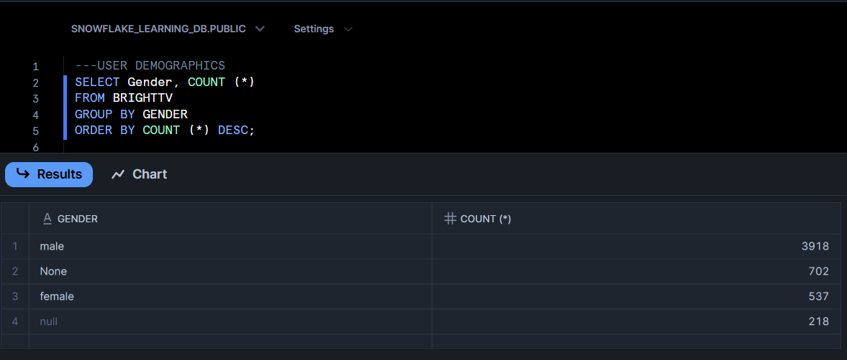

* Used Snowflake to check which race has more people

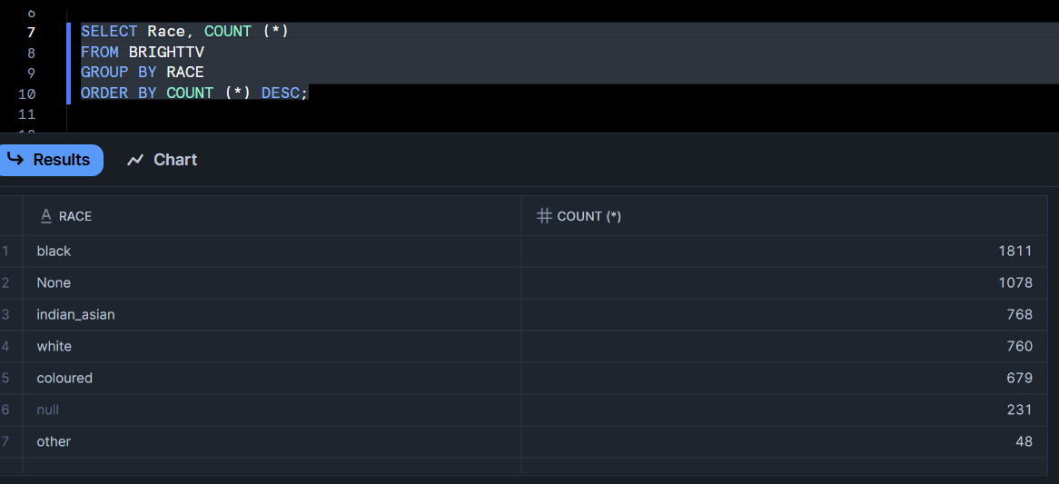

* Data Extraction on Excel via Pivot chart and Pie chart:

Where I was able to calculate the total number of users per gender in percentages.

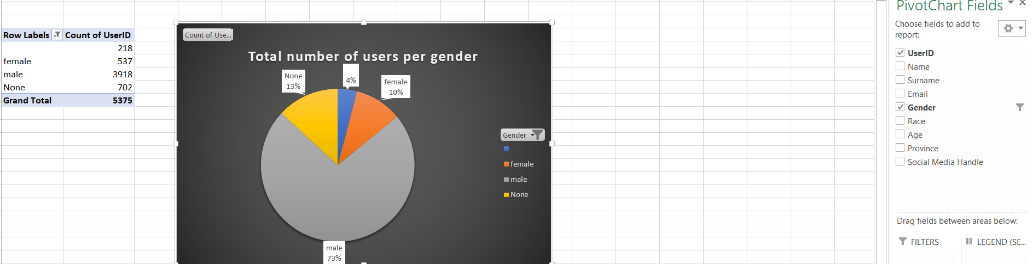

* Data Extraction on Excel via Pivot chart:

Where I was able to calculate the total number of users:

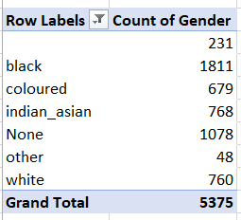

* Data Extraction on Excel via Pivot chart and Column chart:

Where Race was analyzed per gender in order to know which race needs to be more accommodated to, in order to gain more viewership per race.

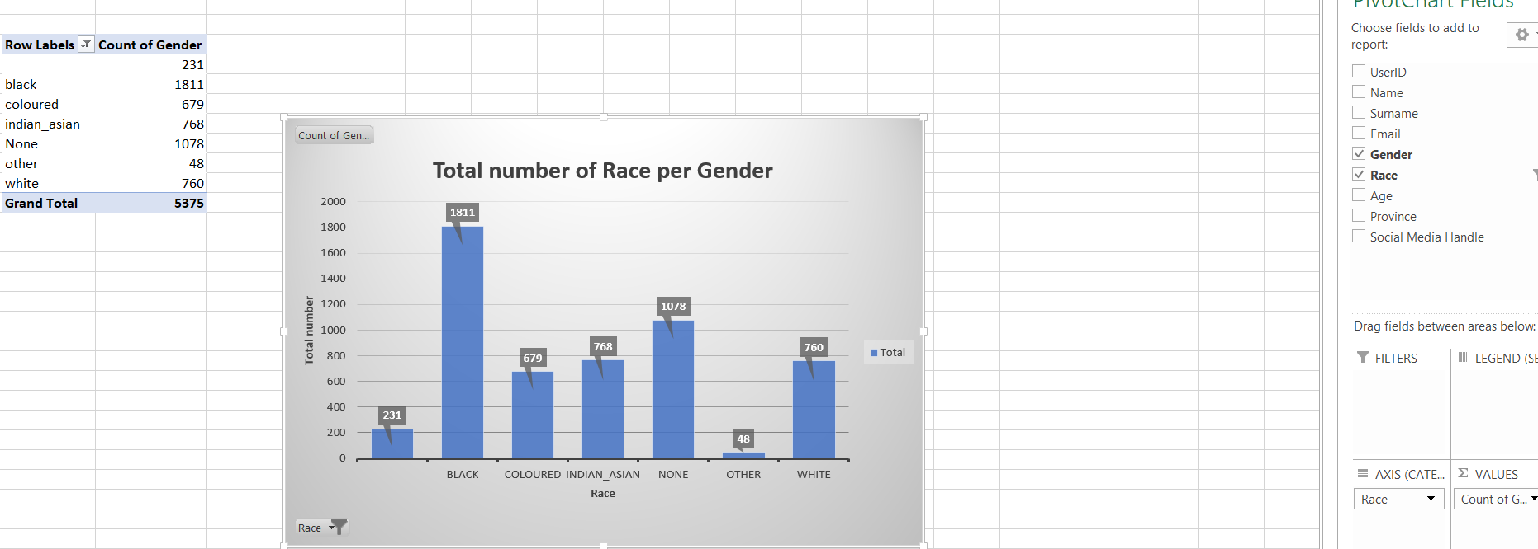

* Data Extraction on Excel via Pivot chart and Line graph:

The line graph was created in order to determine the highest viewership amongst the channels.

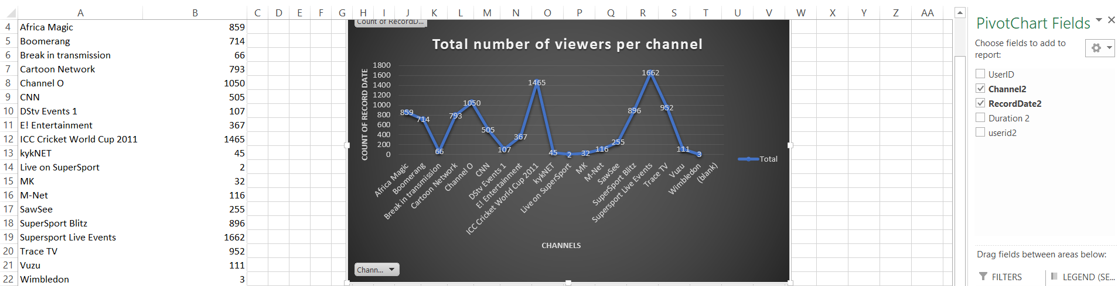

* Data Extraction on Excel via Pivot chart: Average age

To determine the average age most viewers are per province, a pivot chart was created.

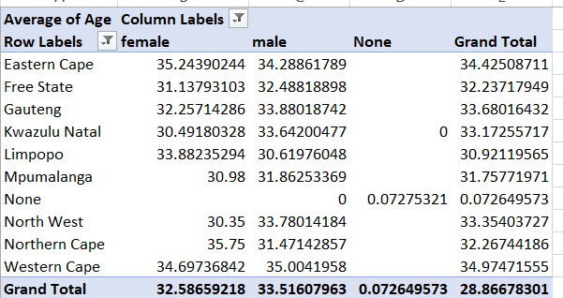

* Data Extraction: A pivot chart was created in order to find the age buckets that usually watch the channels in order to increase the viewership and accommodate the low age bucket and create something more appealing for them.

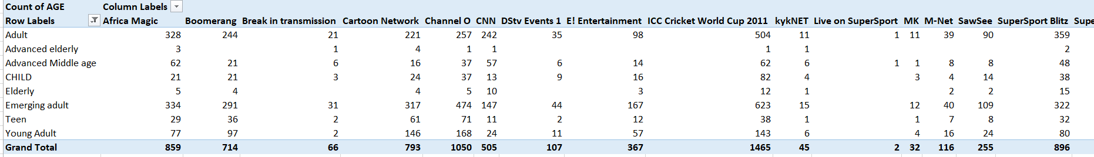

* Data Extraction on Excel: A pivot chart was created in order to which channel is watched more on which days of the week hence time buckets where created

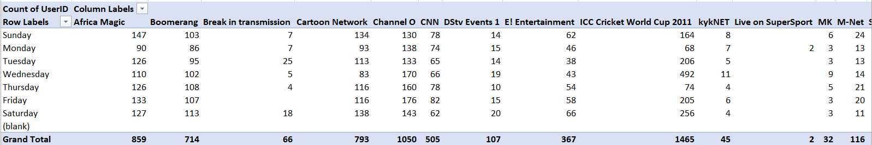

From the channel viewership it was evidently seen that there were 5 popular channels hence the top 5 popular channels were inserted so it is easier to determine which channel is underperforming so attention can be given to it.

Strategies to increase Low-day viewership:

“Monday specials”: Premieres or exclusive releases

Gamification: Rewards for viewing during off-peak days

Nostalgic Content (for 30+ age group)

Initiatives to grow User Base:

Personalized recommendations using AI.

Regional content campaigns (focus on Gauteng, Western cape

Loyalty programs tied to watch-time

Partnerships with mobile data providers for cheaper streaming access.

BrightTv holds a strong position among young, sports-loving viewers.

Tactical improvements in content scheduling and marketing will boost subscriber base.